Round 1: Practice Problem
- Function to Summarize a Text File: Write a function that accepts a filename as a parameter, reads the file, and returns the number of lines, words, and characters in the file.
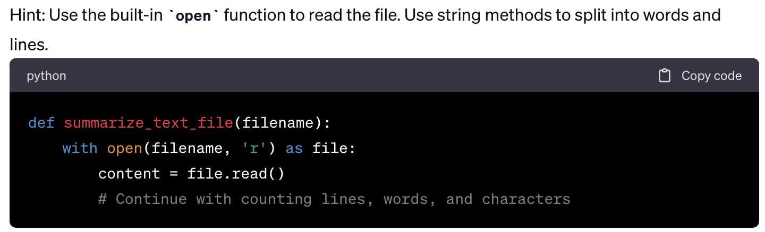
- Palindrome Checker: Create a function that checks if a given string is a palindrome (reads the same backward as forward, ignoring spaces, punctuation, and capitalization).
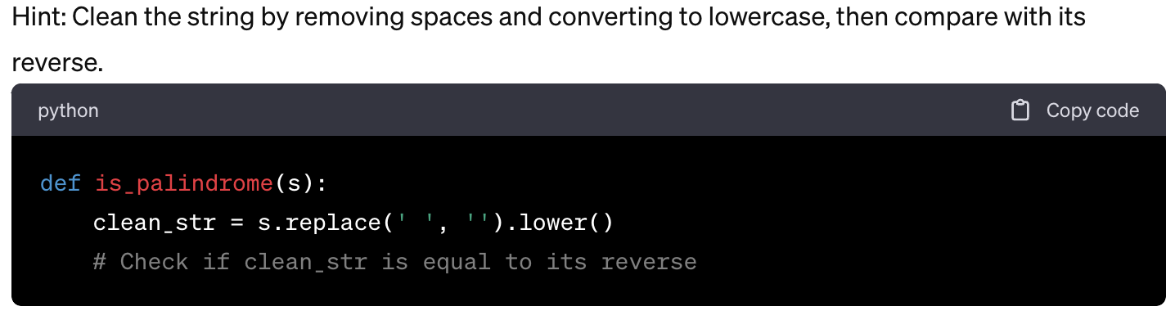
- Basic Calculator: Write a function that takes two numbers and a mathematical operation (add, subtract, multiply, divide) as parameters and returns the result of that operation.
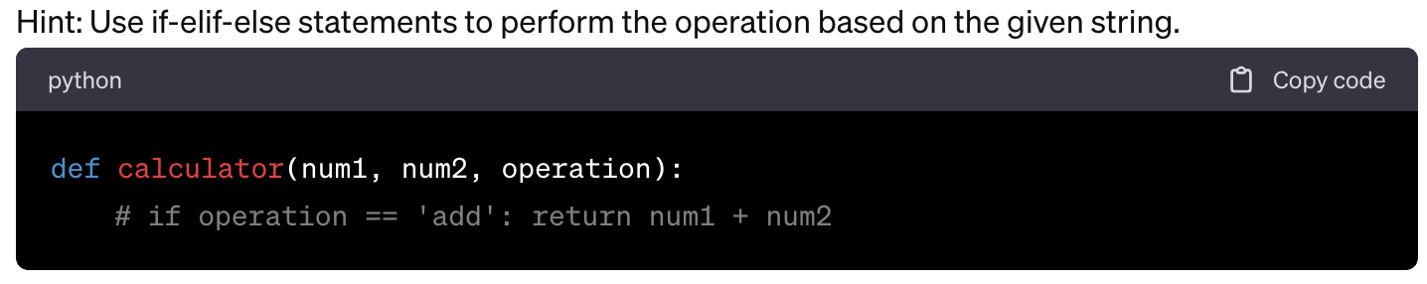
- Frequency Counter: Develop a function that takes a list of numbers and returns a dictionary with keys being the numbers and values being the frequency of those numbers in the list.
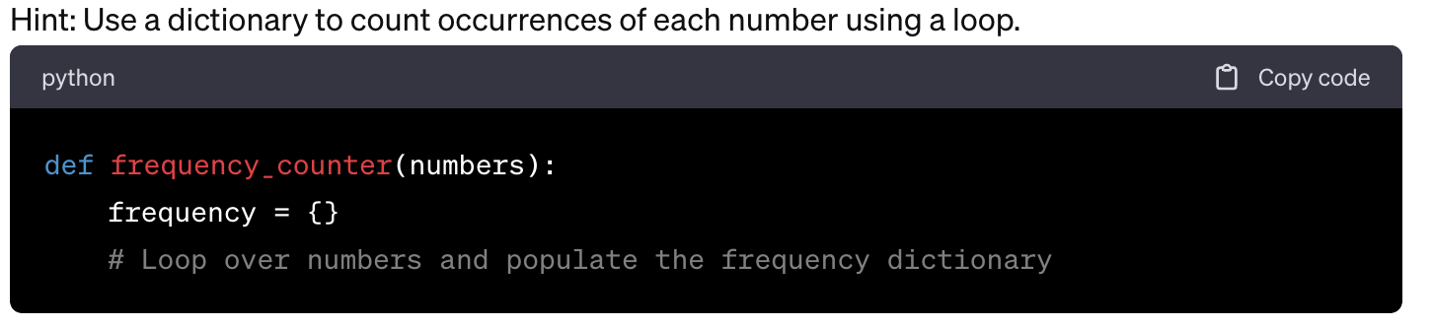
- Data Filter: Write a function that takes a list of dictionaries (representing people, with keys for name, age, and profession) and a profession string, and returns a new list with dictionaries where the profession matches the given string.
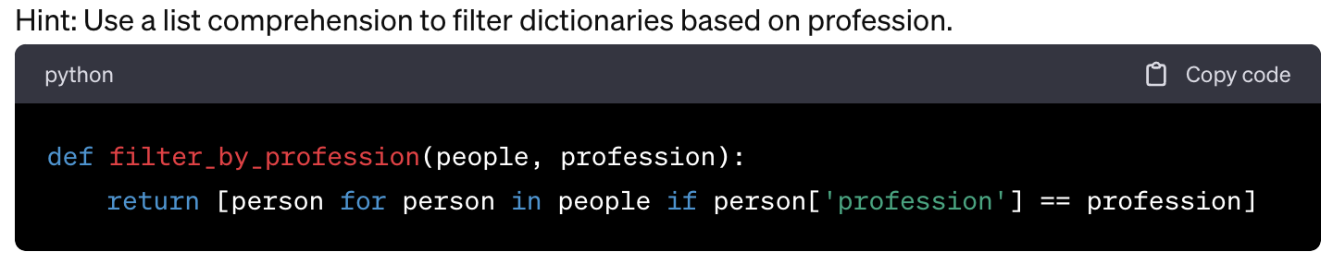
- Temperature Converter: Create a function that converts a temperature from Fahrenheit to Celsius and vice versa, based on a second argument indicating the direction of conversion ('F_to_C' or 'C_to_F').
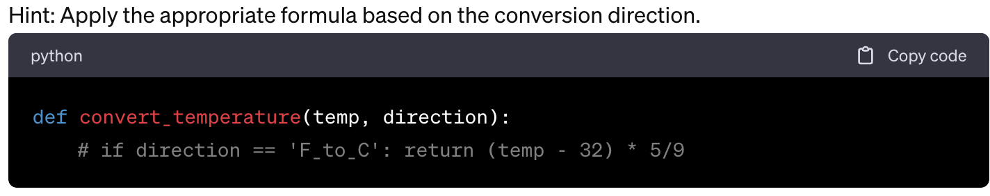
- Prime Number Finder: Write a function that takes an integer and returns a list of all prime numbers up to and including that integer.
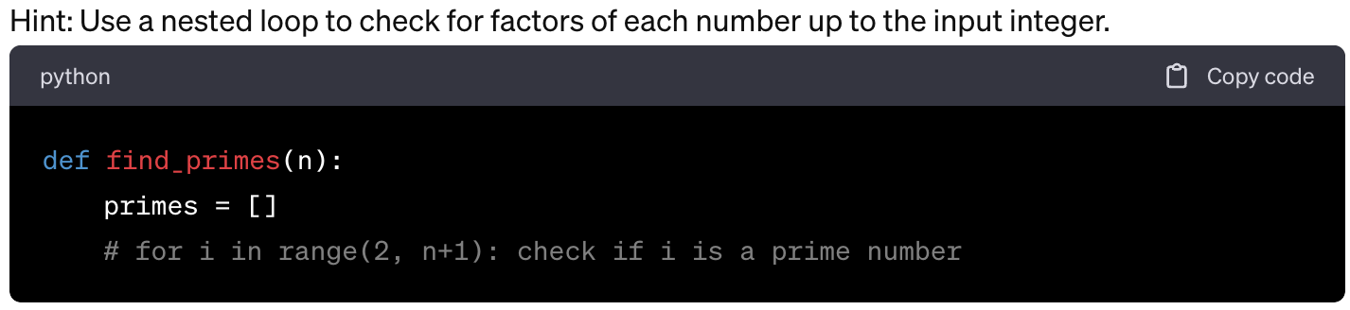
- List Flattener: Develop a function that takes a list of lists and flattens it to a single list without using any built-in Python flattening functions.
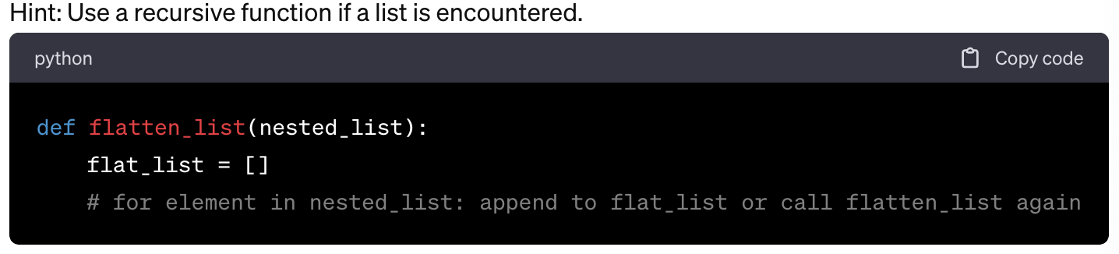
- Unique Elements: Write a function that returns the unique elements in a list.
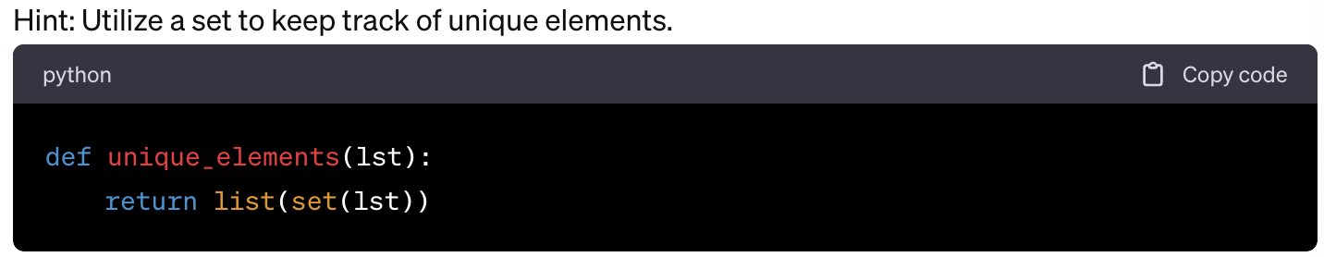
- String Reverser: Create a function that takes a string and returns the string in reversed order without using the [::-1] syntax.
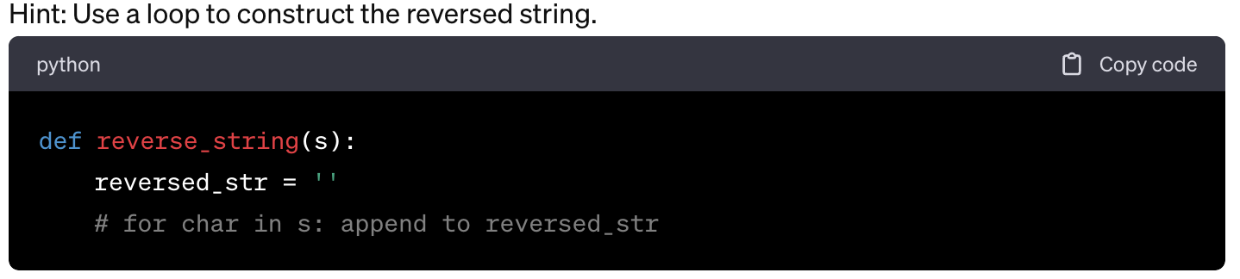
- Dictionary Merger: Write a function that merges two dictionaries. If there is a conflict between dictionaries (same key), the value from the second dictionary should be kept.
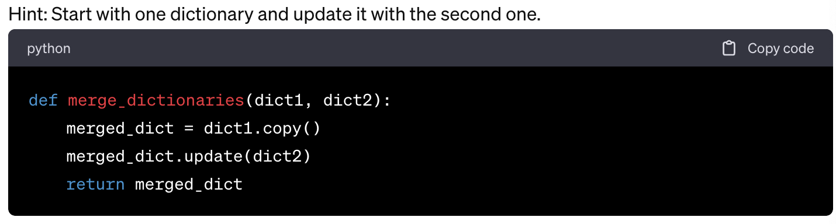

- Multiplication Table Printer: Develop a function that prints out a multiplication table for numbers up to a given number.
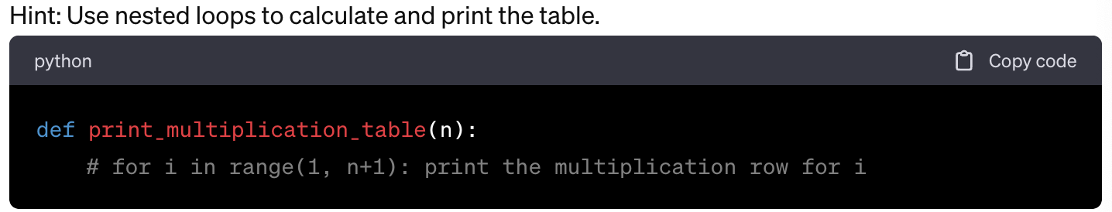
- Email Validator: Write a function that checks if a given string is a valid email address (contains one '@' and at least one '.').
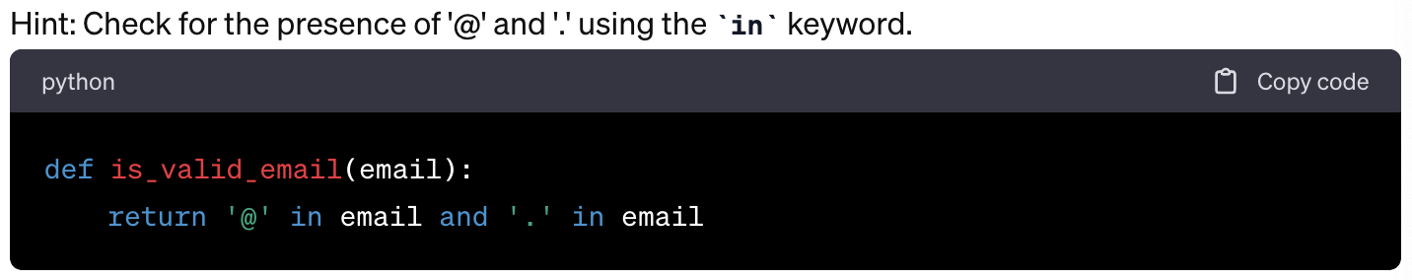
- Word Occurrence in Sentence: Create a function that counts how many times a word occurs in a sentence (passed as a string).
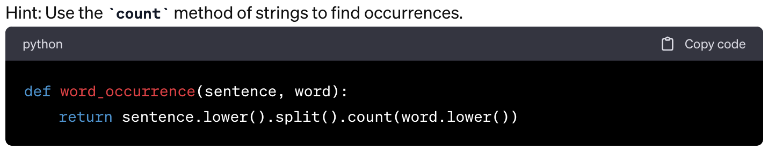
- Fibonacci Sequence Generator: Write a function that returns the Fibonacci sequence up to a given number of elements.
